

**JOMO KENYATTA UNIVERSITY OF AGRICULTURE AND**

**TECHNOLOGY**

**SCHOOL OF PURE AND APPLIED SCIENCES**

**DEPARTMENT OF INFORMATION TECHNOLOGY**

**PROPERTY MANAGEMENT SYSTEM**

This project is submitted to Jomo Kenyatta University of Agriculture and technology in the

Partial fulfillment of Diploma in Information and Technology

## **Declaration**

This presentation is original in every aspect and is being presented for the first time in Jomo Kenyatta University of Agriculture And Technology and is unique.

**SIGNATURE: DATE:**

STUDENT………………………………… …………………………….....

This proposal is submitted with my approval as University Supervisor.

SUPERVISOR…………………………….. ……………………………….

## **Acknowledgement.**

I take this time to thank the following people for helping me through this project. My family for always been by my side. The school for providing the necessary tools to make it easy for research. My supervisor for guiding me through the whole process.

# 

# 

# **Dedication**

This project proposal is my original work and has not been submitted to any institution of higher learning for the award of diploma.

TABLE OF CONTENTS

**Declaration** ii

**Acknowledgement.** iii

**Dedication** iv

**Abstract**

CHAPTER ONE

1.0 Introduction

1.1.1 Population growth in kenya

1.1.2 Housing Kenyans

1.1.3 House hunting in Kenya

1.1.4 Data collection

1..1.5 Overview of the problem

1.2 Statement of the problem

1.3 Objectives

1.3.1 General objectives

1.3.2 Specific objective

1.4 Research questions

Chapter Two

LITERATURE REVIEW

2.0 Introduction

2.1 Technology

2.1.1 Technology in Africa

2.1.2 Technology in Kenya

2.2 Real estate

Chapter Three

Methodology

3.0 Introduction

3.1 System Development Life Cycle

3.2 Methodology used

3.3 Fact finding technology

3.3.1 Interview

3.3.2 Questionnair

3.3.3. Observation

3.4 Conclusion

Chapter Four

FEASIBILITY STUDY

4.0 Introduction

4.1 Types of feasibility study

4.1.1 Technical Feasibility

4.1.2 Economic Feasibility:

4.1.3 Operational Feasibility:

4.1.4 Social Feasibility:

4.1.5 Time Feasibility:

4.2 The feasibiltyreport

4.2.1 Statement of the problem

4.2.2 Summary of the findings

4.3 Conclusion

Chapter Five

SYSTEM DESIGN AND DESIGN TOOLS

5.0Introduction

5.1Design tools

5.1.1 Data flow diagram

5.1.2 Flowchart

Chapter Six

SOFTWARE DESIGN

6.0 Introduction

6.1 User-Register/Login page

6.2 Homepage

6.3 Booking/Buying

6.4 Homeowner’s page

Chapter Seven

SYSTEM IMPLEMENTATION

7.0 Introduction

Chapter Eight

CONCLUSION

APPENDIX

**ABSTRACT**

Real estate in Kenya has been on a tremendous growth. This has been attributed to various issues, infrastructure growth, and a growing middle class. This growth has also been reflected in the country’s GDP, with an estimated contribution of 13.8%. However, with an ever growing population among other things, the country has not been able to sufficiently house its citizenry with the World Bank estimating a deficit of 200,000 units annually. This is a rather shocking statistic considering every single place you turn one sees a new building coming up. This can be attributed to various factors, like the potential client having no clue of the residential building that came up for example in Karen. The property owners on the hand have to rely on unscrupulous methods when deciding on which areas to invest in. This is because they do not have clear statistics on the occupancy of the area. Also, property owners have to avail themselves in their own properties to confirm details on the occupancy of their properties. The Property Management System will avail information on new residential, office and recreational developments that come up to potential tenants. The system will in turn provide the property owners with information on the occupancy of their various properties and their own comfort.

**CHAPTER ONE**

**1.1 Introduction**

**1.1.1 Population growth in Kenya**

The first post-independence census was done in 1969 and at the time the number enumerated by the Kenya National Bureau of Statistics was 10.9 million Kenyans. Since then the number has been on the rise with a current population growth rate of 2.57% annually. The population of Kenya is moreover expected to hit 100million by the year 2058. This is however with a current low population growth as compared to what it was decades ago with the highest population growth ever recorded in the country at 3.14% in 1981. Kenya’s life expectancy also improved from 59 years in 2016 to 62 years in 2018. As at 2019 the number enumerated was approximately 47 million people which are a 2.9% growth from 2009 according to K.NB.S.

**1.1.2 Housing Kenyans**

When the current Government of Kenya got into their second term in 2017 they developed a blueprint, the Affordable housing project, under the Big Four Agenda to help deliver one million units per year to the growing populace. The National Affordable Housing Summit Group of Australia defines it as housing that is reasonably adequate in standard and location for lower or middle-income households and does not cost so much that a household is unlikely to meet other basic needs on a sustainable basis. But the question still remains on whether Kenyans, with the current economic conditions, can actually afford these units. This is not the first time the Kenyan Government has tried housing its citizens, under the 2030 vision blueprint, the Government at the time estimated production of 35000 units annually; however in a period between 2009 and 2012 they only managed to produce 3000 units. The Kenya National Housing Corporation estimates an annual deficit of 200,000 units and an accumulated national deficit of 2 million units. This is not helped by the growing urban population estimated at 4.4% against an average global of 2.1%.Nairobi City, The Capital City of Kenya, bears the biggest brunt in the rural urban migration, as it holds most of the universities and also is home to multinational and local companies that offer employment opportunities and this has lead Nairobi to become the town with the highest population density in East Africa at approximately 57% (estimated 4.397 million Kenyans). However, Plagued by corruption and other factors the Kenyan Government has not been able to house its growing population.

**1.1.3 House hunting in Kenya**

House hunting in Kenya is one of the most daunting tasks. It’s time consuming, since the potential homeowner has to physically visit each and every unit. Its economically draining, potential homeowners are swindled off their money by conmen posing as agents. These agents tend to take potential homeowners in circles before actually connecting them to the landlords while requesting for a ‘small fee’ for their services. Even though good residential units exist, the amount of time, energy and financial resources required to acquire them discourages house hunters and this leaves Kenyans to settle for less.

**1.1.4 Data collection**

The biggest challenge faced by property developers understands the market. “To know what customers want, it's important to collect all the relevant information and insights you can” (Lloyds Bank). Data collection in the real estate requires the property developer to visit their respective properties physically to determine the occupancy of the same. Property developers use data on population distribution to determine the best places to set up properties. Some of this data may not be accurate as property owners have lamented setting up properties and having less to zero occupancy.

**1.1.5 Overview of the system**

The Property Management System will present the potential tenant with a portfolio of available units. The occupancy of these units will also be listed as vacant, booked or occupied. Once the potential tenant identifies the unit that fits their taste, the system will prompt them to enter their details, i.e. their name and I.D number, this is in a bid to book the unit. Once booked, the system gives the tenant a period of 72 hours to change the status of the unit. Failure to do so within the stipulated time the unit’s status automatically changes to ‘vacant’. On the other end the landlord receives a notification of the house booked. When the tenant changes the status of the unit to occupied, the landlord and by extension the property owner gets a full account of the occupancy of the said property.

**1.2 Statement of the problem**

The system provides a one-stop shop for both potential tenants and property owners. The system eliminates the need to physically search for a house and also the need to interact with agents who swindle people off their hard earned money. The system also provides a comprehensive analysis of the property and the amenities provided by the developer. Property owners will not need to physically present themselves in their respective properties to know the details of their occupancy.

**1.3 Objectives**

**1.3.1 General objective**

To provide a one-stop shop for both potential tenants and property owners/developers.

**1.3.2 Specific objectives**

1. To ease the burden of house hunting among Kenyans
2. To provide property developers with information on the occupancy of their respective properties.
3. To provide a platform where potential tenants can interact with their landlords
4. To provide information to the stakeholders in the real estate sector with information on the occupancy of properties in a certain area/region.
5. Help the government understand the state of the real estate in the country

**1.4 Research questions**

How will the system help ease the burden of house hunting?

How will the system provide developers with information on the occupancy of the properties?

How does the system provide a platform for potential tenants and landlords to interact?

How does the system provide information to the stakeholders in the real estate sector with information on occupancy of properties?

How does the government benefit from the system?

**CHAPTER TWO**

**LITERATURE REVIEW**

**2.0 Introduction**

The real estate sector in Kenya has been on the rise for the past decade or so, but the question remains on whether Kenyans are getting the better deal, or are potential tenants getting their return on investment. In this section we look at the growth of both the technology and real estate in Kenya in a bid to make our claim as to why a property management system is essential. And like Rudestam, K.E. and Newton, R.R. (1992), our task is to build an argument and not a library.

**2.1 Technology**

Technology, often referred to as the fourth industrial revolution, has no doubt had an impact on how we run our day today life. This fourth industrial revolution is characterized by the fusion of the digital, biological and physical worlds, as well as growing the utilization of new technology such as Artificial Intelligence (A.I), cloud computing, Internet of Things (IoT) e.t.c. The fourth industrial revolution has ushered in a new era of economic disruption with uncertain socio-economic consequences for the world at large.

Adoption of new technology has, however, not been an easy feat as explained by Everett Rogers when coming up with the diffusion of innovation theory, which looked to explain how the market adopts a new idea, Rogers came up with the five established adopter categories ;

* **Innovators** - These are the early adopters of technology. They always want to be the first to try a new innovation
* **Early adopters -** These are people who represent opinion leaders. They embrace change opportunities
* **Early majority -** They adopt new ideas before the average person only after it has been tried and tested.
* **Late majority -** These people are skeptical of change, and will only adopt a technology after it has been tried by a majority of the population.
* **Laggards -** These people are bound by tradition and are very conservative. They are the hardest of people to get on board with regards to new technology.

The stage at which one adopts new technology is based on various factors which include awareness and the decision to adopt.

Having said that, we will look to understand the growth of technology in Africa and in the country over the past decades to understand where the country stands in terms of technology penetration and how the continent and the country have made use of the same.

**2.1.1 Technology in Africa**

Africa has been playing catch up to the rest of the world as far as development is concerned. However, in the last few decades, there has been a positive stride in the African Governments to jump in on the bandwagon that is the fourth industrial revolution. With the understanding that failure to recognize and capitalize on the fourth industrial revolution will impose considerable risks on African businesses which might lead to the same falling further behind and increasing the global digital divide and lowering the global divide.

Africa’s ICT sector has been largely driven by expanding mobile digital finances. The region had nearly half of global money accounts in 2018 and will see the fastest growth in mobile money through 2025. Mobile technologies in Africa have generated 1.7 million direct jobs both formal and informal. It also has contributed to $144 billion of economic value which is 8.5% of the GDP in sub-Saharan Africa. (Njuguna Ndung’u and Landry Signe, 2020). This has been accelerated by the ever growing internet and mobile penetration in Africa. In 2018 mobile phone access in Africa was only 44.6 mobile cell phone per 100 people down from 92.8 in 2001 and is expected to grow to 19.4 per 100 people in 2030. Internet penetration has also been on a steady growth from 55.4% points in 2017 to 63.8% in 2017 and is expected to grow to 21.8% by 2030. The covid 19 pandemic presented a new front in the growth of the ICT sector in Africa. The pandemic saw an accelerated growth of digitization of economies and societies. This has been witnessed by the growth in adoption of the internet, it is estimated that 28% of the population in sub-Saharan Africa was connected to the internet.

Africa in a bid to keep and retain competitiveness, it should keep abreast of technological developments and market trends.

Bringing it closer home, there is established the East African Community that looks to grow the region both economically and technologically. According to the World Bank the ICT sector has outperformed other sectors as far as growth is concerned, expanding by 23% annually. In 2000, the East African Community (Kenya, Uganda and Tanzania as of then) had approximately 250000 internet users and by the end of 2014 the region had approximately more than 29 Million people connected to the internet.

**2.1.2 Technology in Kenya**

There is no doubt that there has been tremendous growth in the technology space in Kenya, this is witnessed by the sector’s contribution to the G.D.P which is estimated at 8% contribution to the country’s G.D.P. According to the Business Monitor International (B.M.I), Kenya’s IT market was valued at $635 million as at the end of 2020. This has seen the Government of Kenya take the initiative to grow the sector through coming up with the initiative dubbed The Digital Economy Blueprint.

**2.2 Real estate**

With a population growth of 2.6% per annum and an urbanization population of 4.4%, Kenya’s need to house its population grows by the day. However, according to the World Bank, Kenya is facing a 200000 units annually house deficits with an accumulated deficit of over 2 million units.

**CHAPTER 3**

**METHODOLOGY**

**3.0 INTRODUCTION**

Methodology is the combination of best practices, procedure, rules and guidelines in one word the methods, of the specific field of science and art by which professionals, specialists and researchers can conduct their projects, research, development and project activates. During development, a software goes through the Software Development Life Cycle (SDLC) which represents all the activities and stages required for a software to go through the phases.

**3.1 Software development life cycle.**

There are different software development life cycle models each with its merits and demerits. The software development team chooses the appropriate life cycle model depending on the kind of software to be developed.

Some of the models include;

* + - 1. **Agile methodology**

This method deploys continuous increments of development and testing, although this increments are slow, they are run concurrently and done throughout the software’s life cycle.

*Advantages*

* The customer is involved in every process of the development
* It embraces change, as reviews are done every now and then
* It maintains simplicity

*Disadvantages*

* It’s suitable for large complex development.
* Since it depends heavily on customer interaction, the customers can give misleading information
  + - 1. **Waterfall methodology**

This is a design methodology that divides the development into separate phases and each phase has to be completed before moving to the next phase.

*Advantages*

* It allows for departmentalization
* Each stage is clearly defined and understood
* The processes are well documented

*Disadvantages*

* The amount of risks associated are high because of the departmentalization
* It does not leave room for change
* It cannot be done for big and long projects
  + - 1. **Spiral model**

In this model the software undergoes through iterations called spirals. With each iteration around the spiral, more complete versions of the system are built.

*Advantages*

* It can accommodate changes
* The customers and end users can see the prototypes early on.
* The requirements are captured early on and accurately.

*Disadvantages*

* The model is more complex to understand, hence it is not suitable for small projects
* The spiral may go on indefinitely since it doesn’t present a clear end to the process
  + - 1. **Prototyping**

Here software prototypes showing the functionality of the product under development are built early. Customer feedback is used to enhance the products functionality.

*Advantages*

* The customer is highly involved early on in the development process.
* Users get a better understanding of the product.
* There is better solution since feedback is delivered early on.

*Disadvantages*

* It is too expensive as a model of development.
* It is too complex

**3.2 Methodology used**

This system employed the Agile methodology for this particular project. The Agile methodology is an incremental model method that employs incremental changes during the development. This methodology involves end users and customers in the development process.

This method emphasizes on four core values;

Responding to change over following a plan

Working software over comprehensive documentation

Customer collaboration over contract negotiation

Individual and team interactions over processes and tools

The most common agile methods are

**Scrum –** It concentrates on how to manage tasks within a team-based development environment.

**Crystal methodologies –** This methodology is based on three concepts;

Chartering

Cyclic delivery

Wrap up

**Dynamic Software Development Method –** This is a Rapid Application Development (R.A.D) that requires end users to be involved actively and teams given power to make decisions.

**Feature Driven Development (FDD) –** This model focuses on designing and building.

**Lean Software development –** This model focuses on reduction of cost while increasing productivity.

**Extreme Programming (XP)** - This model encourages frequent release of the product to customers which improves the productivity of the system.

**3.3 Fact finding techniques**

These are processes employed to collect on data on the various issues involving the system. From understanding the problem, understanding the system requirements to understanding customer needs and expectations.

There are various fact finding tools that can be used, they include;

**3.3.1 Interviews**

This is the most common used technique. It involves acquisition of information from interviewees using face to face interactions. The face to face interactions help the interviewer gather more information from the interviewee using follow up questions.

There are different types of interviews

1. Open ended interviews – This allows the interviewer to answer in any possible way
2. Closed ended interviews – This restricts the interviewer to only answer the questions provided

Below is a snippet of an interview with a potential homeowner

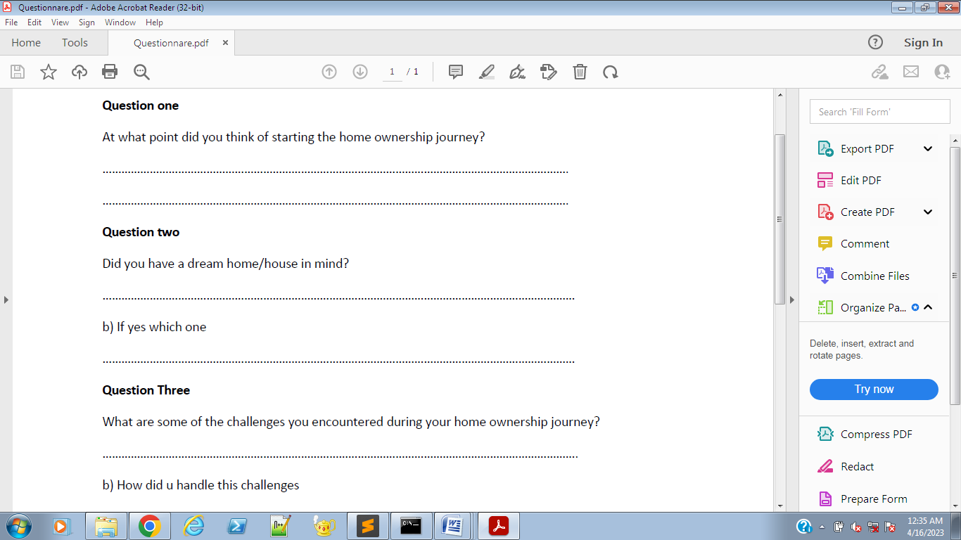

*Figure 1.0 Interview for a potential home owner*

*Advantages of interviews*

* The interviewer can gather more information on a particular question since the interview is face to face.
* It’s relatively cheap
* There is a less chance of the interviewee gathering false information.

*Disadvantages of interviews*

* It’s time consuming and very tiresome.
* Interviews can be impractical if the location is inaccessible by the interviewee
* It’s quite costly

**3.3.2. Questionnaires**

These are documents filled with questions that the responded can answer. They are mainly used when the scope of information to be gathered or rather when the responders are many.

There are two types of questionnaires:

1. Free-format questionnaires (open ended) - They allow the responded to answer in any way they see fit. They include follow up questions.
2. Fixed- Format questionnaires (closed ended) – They restrict the responded to only answer the questions provided in the questionnaire.



*Figure 2: Questionnaire given to a property owner*

*Advantages of questionnaires*

* It is a cheap method of gathering information from a large crowd of responders
* They are cheaper than interviews
* They allow for anonymity

*Disadvantages of questionnaires*

* There isn’t guarantee that the responders will be truthful
* There aren’t follow up questions
* They are difficult to prepare

**3.3.3 Observation**

This is a technique that involves gathering information through observing. This includes following the day to day routine of the people to be observed. For our system, we observed the process of house hunting. Following on various potential home owners as they embarked on the journey to acquire their dream homes. It also involved following on landlords as they took stock of the day to day management of their properties.

*Advantages*

* There is first hand information gathering
* It provides an easier way to understand the system

*Disadvantages*

* It is expensive
* It is tedious and time consuming
* It is quite impractible if the area of study is large

**3.4 Conclusion**

Data analyzed from the above showed a big gap between potential home owners and property developers. The idea of tamarcing to look for house takes a toll on a lot of people. The challenges faced are as diverse as they come. The number of untrustworthy people out there ready to swindle people out of their hard earned money grows by the day. Finding a suitable place for your forever home is headache to so many Kenyans. This formulated a template from which to work on.

**CHAPTER FOUR**

**FEASIBILITY STUDY**

**4.0 Introduction**

This is a detailed analysis of the proposed system. It is an assessment of the proposed system. It is done by listing the merits and demerits of the proposed system to ascertain its viability and the likelihood of its succession or failure. It involves analysis of the technical, economical, legal operational and time feasibility.

*Advantages*

* Evaluates the requirements needed
* Provides a framework with which to base the proposed system on.
* It provides a better framework and guideline for the team to use during development.

**4.1 Types of feasibility studies**

**4.1.1 Technical feasibility**

This is a study carried out to check whether the company has enough technical resources for the proposed system. If the resources exist, then a determination has been made on whether the team can properly utilize them.

**4.1.2 Economic feasibility**

This is a financial plan developed to determine whether the proposed system is economically viable. It is also used to determine what the proposed system will do financially for the company. This is basically a plan on whether the company can afford the requirements, the hardware, software and the labor too.

**4.1.3 Operational feasibility**

This is done to establish the operational viability of the system. This is done to establish how the proposed system fits into the current system. How the end user might respond to the proposed system. Also whether the employees can handle the proposed system to enable profitability of the proposed system to the overall company’s strategic plan.

**4.1.4 Social feasibility**

This is a study to determine the impact of the proposed system to the stakeholders of the system. They include the users of the system, the Government and the overall community at large.

**4.1.5 Time feasibility**

This is done to estimate how much time it would take for the proposed system to complete the system. It sets a time frame for the team to complete the system.

**4.2 The feasibility report**

After the above mentioned study, the outcome is a feasibility report that details the scope and nature of the proposed system. It entails what is to be done, how it is to be done, the timeframe to accomplish it and whether the company possess the required financial and technical muscle to undertake the proposed system development.

**4.2.1 Statement of the problem**

The gap between potential home owners and property developers is high. This is brought about the tedious and inexpensive process of house hunting. Finding a perfect property in a perfect location is a taunting task to many Kenyans. This is also enabled by the fact that most potential home owners don’t have enough portfolios on the available properties.

**4.2.2 Summary of findings and recommendations**

Below are some of the findings from the study;

* 1. The resources required to develop the system are readily available. The system is already in place since property owners and potential homeowners already exist.
  2. Some of the other resources are readily available since it involves developing of a web based app for the potential home owners and property developers to use.
  3. The financial impact of the proposed system include;

1. Profits to the home owners will be marginally increased; this is due to the fact that the property owner will have complete autonomy of their properties.
2. The potential home owners will be saved a lot of money that would have been otherwise lost in the hunt due to swindlers posing as home owners and end up delivering nothing
3. Development and deployment of the proposed system will not cause an arm and leg because not a lot is required to the same.
   1. The proposed system is developed in conjunction with the stakeholders; this therefore reduces the risk of the users not been content with the system.
   2. This also helps the user understand the operation ability of the system.
   3. The impact to the society will be large and wide. This includes;

* Helping the government understand the landscape of the real estate market
* This system will significantly improve the government revenue collection and hence an increase in the country’s Gross Domestic Product( G.D.P)
* The tedious and inexpensive process of house hunting will be significantly reduced.
  1. The time frame of the system is well established.

**4.3 Conclusion**

The study established that the proposed system will have a positive impact not just in the company but also in the larger society. The study established that the financial impact of the proposed system far out way any cons.

**CHAPTER FIVE**

**SYSTEM ANALYSIS AND DESIGN TOOLS**

**5.0 Introduction**

These are activities that help transform the requirements into an actual system. It specifies both the functional and non-functional expectations from the software.

Design tools are tools that show the flow of data through the system.

**5.1 Design Tools**

**5.1.1 Data Flow Diagram (DFD)**

This is a tool that shows the flow of data through the system. It shows the input of data how data is distributed in the system and eventually how it is stored.

***Components***

Entity – This are sources and destinations of data.

Data storage -

Process – This represent actions taken on the data.

Data flow – Shows the movement of data

Output

Tenant’s data

Property Management System

Potential home owners

Properties

*Figure 3. A DFD diagram showing the flow of data in the proposed system*

**5.1.2 Flowchart**

This is a diagrammatic representation of how the system works. It shows the flow of data and processes of a system from the start to the end

***Components***

Start/stop – They denote the start of the process and the end of the project

Input – They are used to show user inputs

Decision – Used to show a decision to be made. This is usually in question form

Process – Shows a process to be undertaken

Direction – This shows the direction to the next process

Connector – Connects two processes.

Storage

NO

Register

Book unit

Is the user registered?

Yes

Does the unit exist?

Search for unit

*Figure 4. A flowchart showing the flow of data in the proposed system*

**CHAPTER SIX**

**SOFTWARE DESIGN**

**6.0 Introduction**

This is the process of transforming the user requirements into a suitable program/ software. The design will showcase graphical user interface, display how the user will go about through the web application.

**6.1 User-register/login page**

The user, in this case, the potential home owner, would be required to register in order to be allowed to book a unit

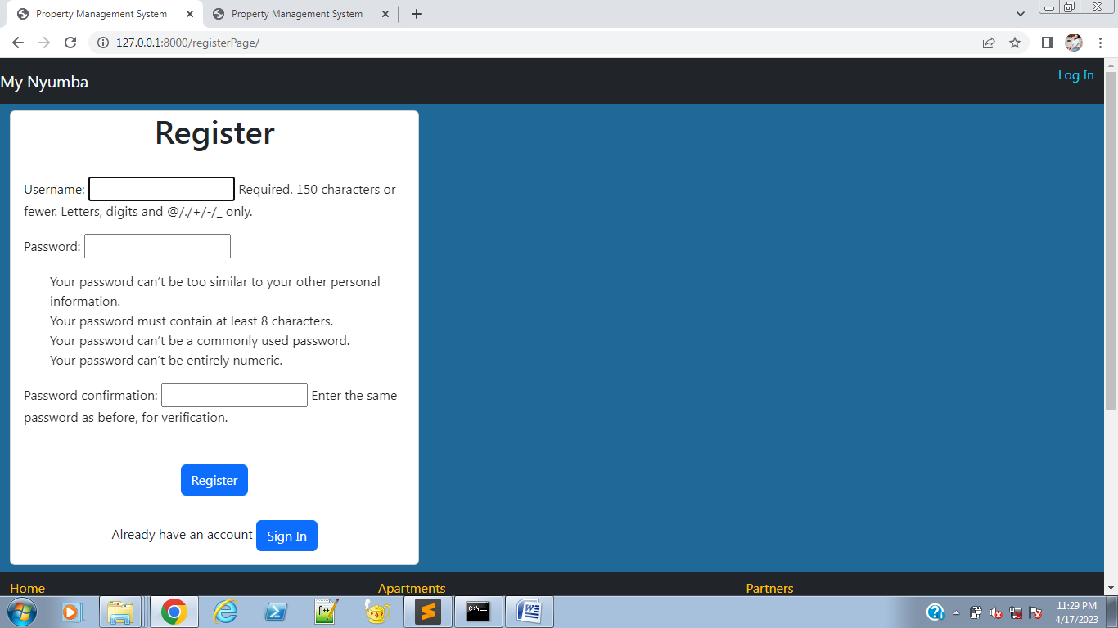

*Figure 5. The registration page*

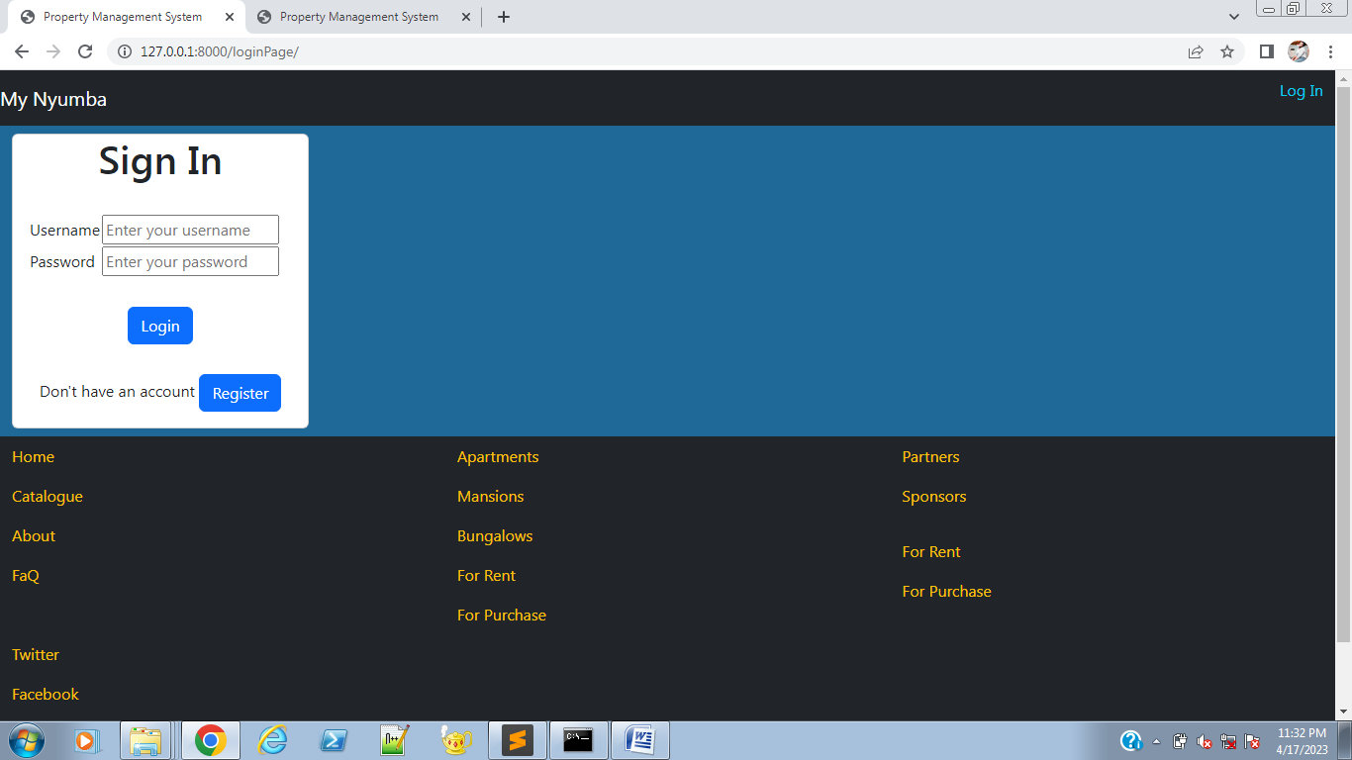

*Figure 6. The sign in page*

The user will then be required to sign in

**6.2 Homepage**

The user is then taken to the homepage where they are presented with a catalogue of homes and units available in the market. The properties are listed with various attributes like location, price, type of property and number of rooms.

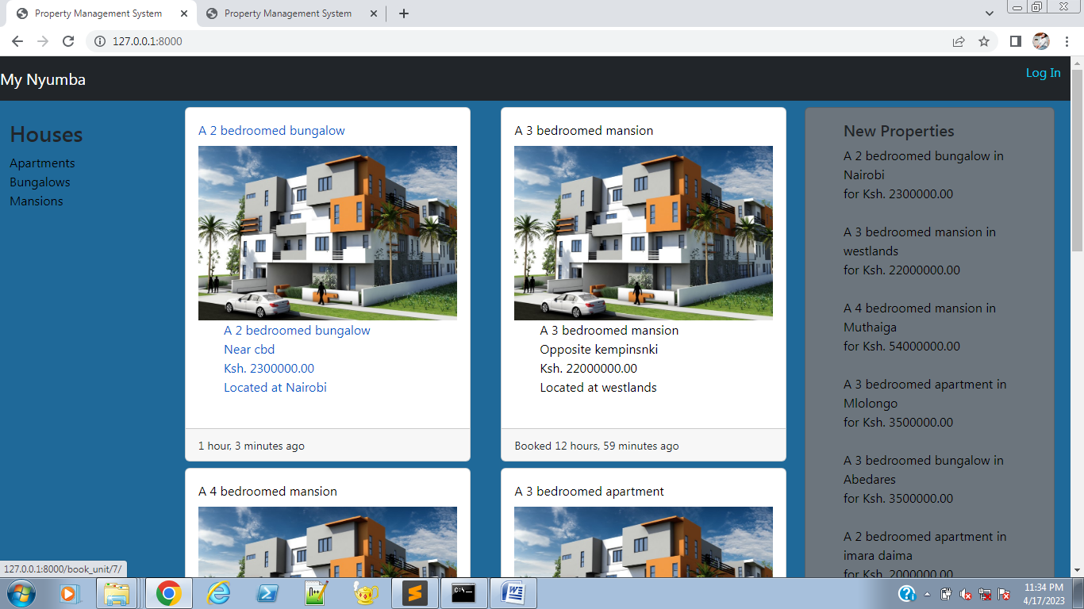

*Figure 7 the homepage*

**6.3 Booking/ buying a unit**

On click the user is taken to a page that allows one to either book the unit or buy the unit. This is only possible if the user is logged in.

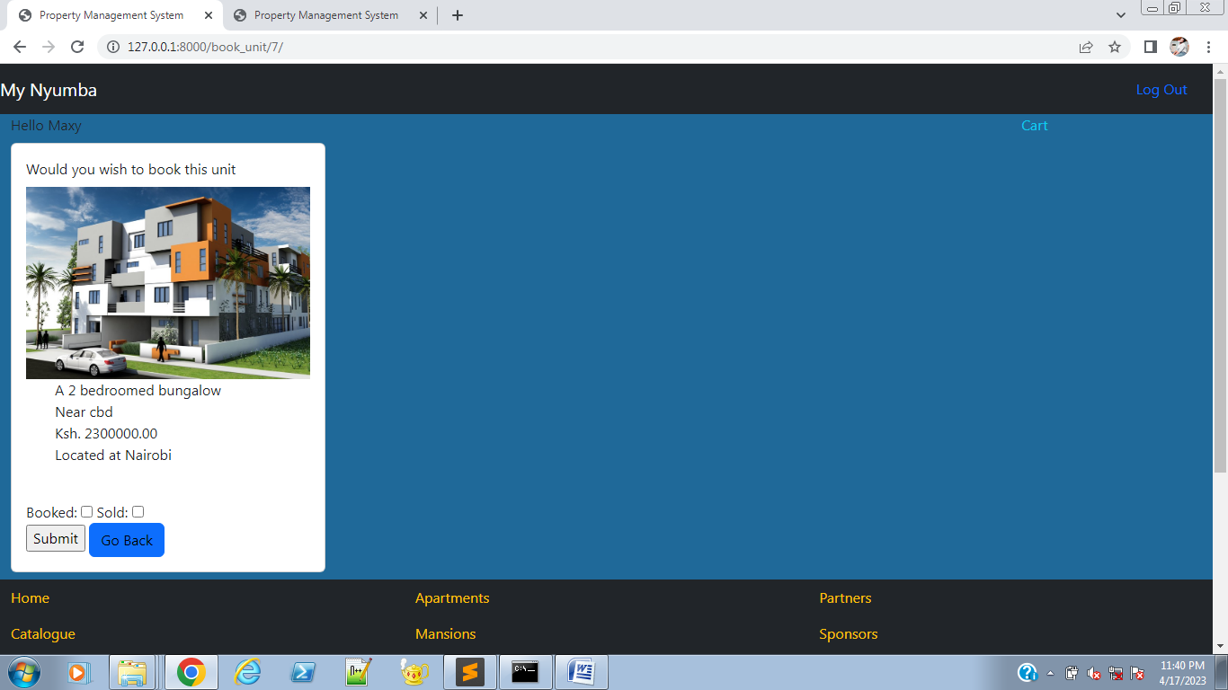

*Figure 8 The booking/ buying page*

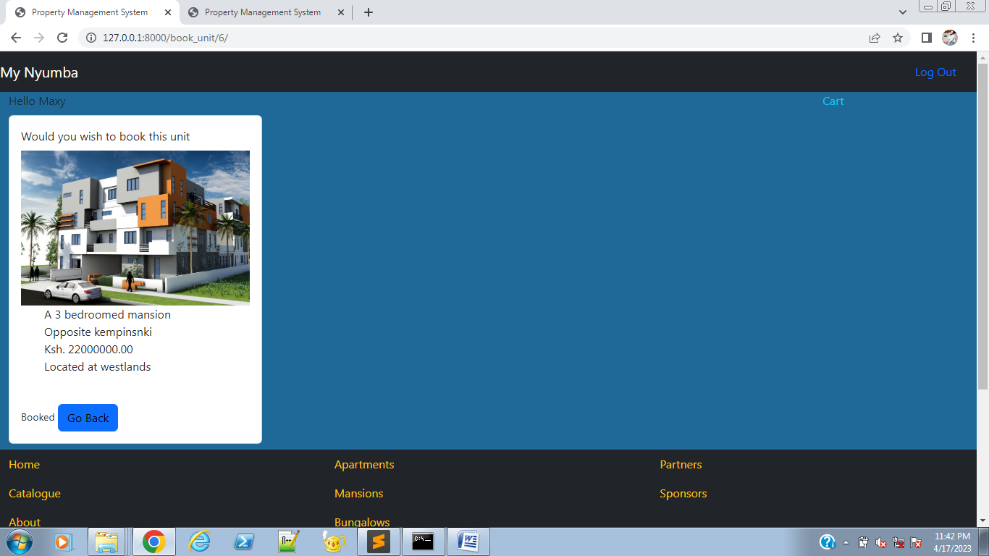

*Figure 9 the page showing a booked house*

**6.4 Homeowner’s homepage**

The homeowner’s page is different from that of a potential homeowner. It includes buttons to add a unit and also allocate a unit to a homeowner. It also includes a page to see the units that are both booked and sold.

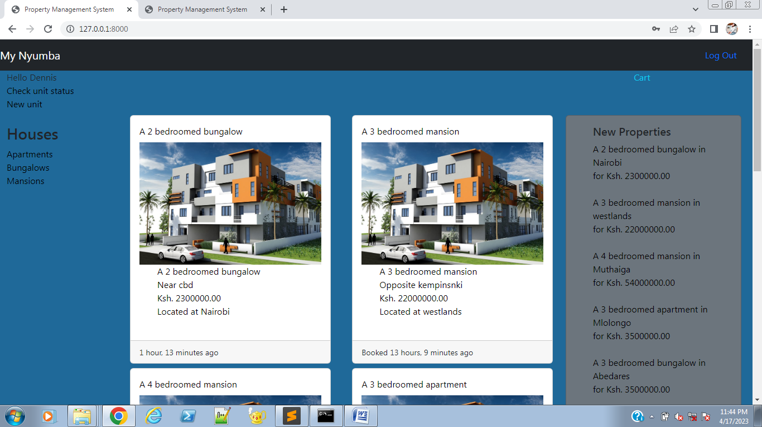

*Figure 10 the homeowner’s homepage*

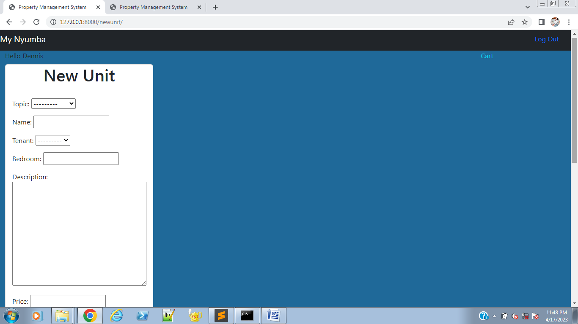

*Figure 11 the page to add a new unit by the tenants*

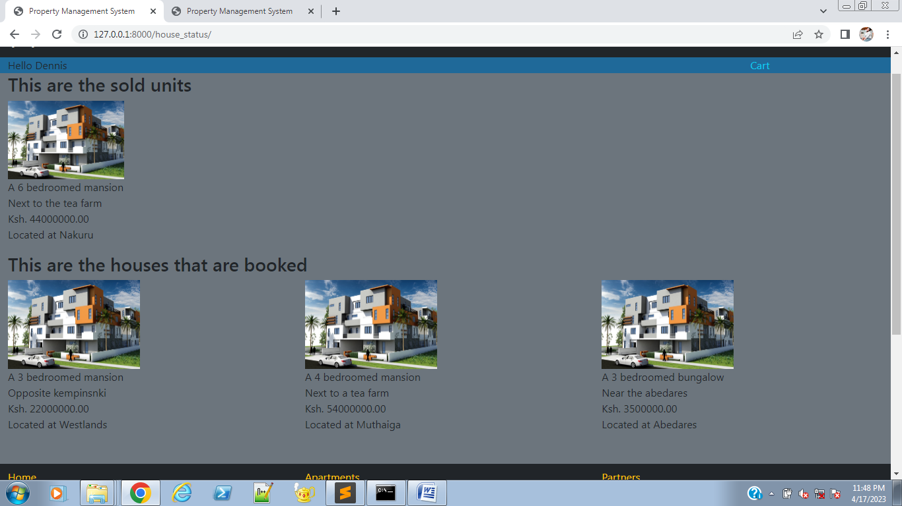

*Figure 12 the sold/ booked page*

**CHAPTER SEVEN**

**SYSTEM IMPLEMENTATION**

**7.0 Introduction**

This is a process within which the system is complete and it is put out to the public to use. Implementation can be done in;

1. Phases – This is when the system is put out to the users in intervals. This is mainly to test the user’s reaction to the system and check where changes need to be done.
2. Direct changeover – This is when the system is put out all at once for the users.
3. Parallel – This is when an old system are run together, while the old user is slowly phased out

The property management system employed the phased implementation. This was necessitated by the fact that we had chosen to go with the agile method of development. The input from the stakeholders was well documented and used to make the system better.

**CHAPTER EIGHT**

**CONCLUSION**

With the growing economic situation in the country, it is incumbent on the locals to save up on any little money they make. It is also incumbent on the Government to have a better understanding the places to make investments. The real estate sector plays a huge role in the country’s Gross Domestic Product (G.D.P), its only logical for the Government to invest highly on the real estate sector. The private sector too is not to be left behind especially with the increase in Public Private Partnerships (P.P.Ps).

The proposed system will enable all of the above stakeholders acquire their desired goals. It eases the work load that goes into house hunting. Reducing risks of swindlers. Reduce risks of getting acquiring a unit that is not in a suitable place. It also helps home owners assess and take stalk of their properties.

**APPENDIX**

**TIMEPLAN**

|  |  |  |  |  |  |  |  |  |  |  |  |  |
| --- | --- | --- | --- | --- | --- | --- | --- | --- | --- | --- | --- | --- |
| **Activity** | Time Duration(Weeks) | | | | | | | | | | | |
| **Weeks** | 2 | 4 | 6 | 8 | 10 | 12 | 14 | 16 | 18 | 20 | 22 | 24 |
| **Feasibility Study** |  |  |  |  |  |  |  |  |  |  |  |  |
|  |  |  |  |  |  |  |  |  |  |  |
| **Proposal writing** |  |  | |  |  |  |  |  |  |  |  |  |
|  |  |  |  |  |  |  |  |  |  |
| **System Analysis** |  |  |  |  |  |  |  |  |  |  |  |  |
|  |  |  |  |  |  |  |  |  |  |  |  |
| **System Design** |  |  |  |  |  |  |  |  |  |  |  |  |
|  |  |  |  |  |  |  |  |  |  |  |  |
| **Coding and Implementation** |  |  |  |  |  |  |  |  |  |  |  |  |
|  |  |  |  |  |  |  |  |  |  |  |  |
| **Testing** |  |  |  |  |  |  |  |  |  |  |  |  |
|  |  |  |  |  |  |  |  |  |  |  |  |
| **Conversion and Maintenance** |  |  |  |  |  |  |  |  |  |  |  |  |
|  |  |  |  |  |  |  |  |  |  |  |  |

**FINANCIAL PLAN**

|  |  |  |  |
| --- | --- | --- | --- |
| **Item Particulars** | **Quantity** | **Description** | **Total Price in Ksh.** |
| Pc machine | 1 | To be used for writing the documentation as well as the code | **20000** |
| Backup CDs | 3 | The CDs will be required for keeping a record of the information | **100** |
| Stationaries | Printing  Papers | Printing papers will be required for a physical documentation of  Of the project. | **1400** |
| Wi-Fi | 1 | Internet will be required to conduct research. | 1500 x 3  **4500** |
| Flash Disk (32GB) | 1 | Will cater for transfer of research, analysis and implementation documents between workstations and presentation venues. | **2000** |
| Miscellaneous |  | Any other cost not catered for. | **2,500** |
|  |  | **TOTAL**  **AMOUNT** | **30,500** |

**REFERENCES**

Njuguna Ndung’u and Landry signee, 2020

Kenya National Bureau of statistics, 2020-2021

[www.kba.co.ke/housing-price-index/](http://www.kba.co.ke/housing-price-index/)issue 1 to issue 15

[cytonn.com/blog/article/current-real-estate-trends-in-kenya-and-how-they-](https://cytonn.com/blog/article/current-real-estate-trends-in-kenya-and-how-they-)affect-investors

[worldbank.org/en/country/kenya/publication/kenya-needs-2-million-more-low-income-homes-building-them-would-boost-its-economic-growth](https://www.worldbank.org/en/country/kenya/publication/kenya-needs-2-million-more-low-income-homes-building-them-would-boost-its-economic-growth)

[www.brookings.edu/techstream/the-promises-and-perils-of-africas-digital-revolution/](http://www.brookings.edu/techstream/the-promises-and-perils-of-africas-digital-revolution/)

[/2019/12/research-how-technology-could-promote-growth-in-6-african-countries](https://hbr.org/2019/12/research-how-technology-could-promote-growth-in-6-african-countries)

[www.weforum.org/agenda/2022/02/3-ways-tech-and-innovation-can-push-africa-to-the-next-level-of-economic-growth/](http://www.weforum.org/agenda/2022/02/3-ways-tech-and-innovation-can-push-africa-to-the-next-level-of-economic-growth/)

<https://unctad.org/system/files/official-document/iteipcmisc13_en.pdf>

https://kam.co.ke/technology-key-future-manufacturing/